Final Project: Multi-Genre Thematic Unit

Table of Contents
Multi-Genre Thematic Unit Planning Guide 3
Multi-Genre Thematic Unit Plan 10
Daily Lesson Plans 16
Reflections 36
References 43
Appendices 41

Multi-Genre Thematic Social Studies & Literacy Unit Planning Guide
(Source – MPE Regional Training: Common Core and ELA)

NAME:

CONTENT AREA/SUBJECT: Social Studies GRADE LEVEL/COURSE: 5th Grade

The History of Space Exploration

What is the topic/big idea for this content area unit? The history of space exploration and its impact on our society.
What is the essential question for the unit (real-world connection)? Since the space exploration missions in the 1950s, men and women have put people in space and on the moon, uncovered life-like evidence on Mars, mapped new planets with the Hubble Telescope, and developed weather and communication satellites. What discoveries have been made through space exploration since that time, and what discoveries can be expected through space exploration in the future?
CONTENT AREA Standards selected for this unit:
2011 Mississippi Social Studies Framework: U.S. History
- Time, Continuity, and Change: Students focus on how the world has changed in order to gain perspective on the present and the future.)
- Individuals, Groups, and Institution: Students study interactions among individuals, groups, and institutions.
- People, Places, and Environments: Students utilize technological advances to connect to the world beyond their personal locations. The study of people, places, and human-environment interactions assists learners as they create their spatial views and geographic perspectives of the world.
- Power, Authority, and Governance: Students study how people create and change structures of power, authority, and governance.
- Global Connections: Students analyze patterns and relationships within and among world cultures.
- Science, Technology, and Society: Students study relationships among science, technology and society.
Standards listed from the Mississippi Department of Education’s website (http://www.mde.k12.ms.us):
- MSCCRS.RH.6-8.4 Students will be able to determine the meaning of words and phrases as they are used in a text, vocabulary specific to domains related to history/social studies.
- MSCCRS.RST.6-8.4 Determine the meaning of symbols, key terms, and other domain-specific words and phrases as they are used in a specific scientific or technical content relevant to grades 6-8 topics.
- MSCCRS.RST.6-8.7 Integrate quantitative or technical information expressed in words in a text with a version of that information expressed visually (e.g., in a flowchart, diagram, model, graph, or table).
- MSCCRS.RST.6-8.10 By the end of grade 8, read and comprehend science/technical texts in the grades 6-8 complexity band independently and proficiently.
- MSCCRS.WHST.6-8.2d Use precise language and domain-specific vocabulary to inform about or explain the topic.
- MSCCRS.WHST.6-8.7 Conduct short research projects to answer a question (including a self-generated question), drawing on several resources and generating additional related, focused questions that allow for multiple avenues of exploration.
- LITERACY [ELA] Standards selected for this unit:
2016 Mississippi English Language Arts Framework

Literacy (ELA) Standards:
- MSCCRS.RL.6.1 Cite textual evidence to support analysis of what the text says explicitly as well as inferences drawn from the text.
- MSCCRS.RL.6.2 Determine a theme or central idea of a text and how it is conveyed through particular details; provide a summary of the text based upon this determination.
- MSCCRS.RL.6.4 Determine the meanings of words and phrases as they are used in a text, including figurative and meanings; analyze the impact of a specific word choice on meaning and tone.
- MSCCRS.RL.6.6 Explain how an author develops the point of view of the narrator or speaker in a text.
- MSCCRS.RL.6.7 Compare and contrast the experience of reading a story, drama, or poem to listening to or viewing an audio, video, or live version of the text, including contrasting what they “see” and “hear” when reading the text to what they perceive when they listen or watch.
- MSCCRS.RL.6.10 By the end of the year, read and comprehend literature, including stories, dramas, and poems, in the grades 6-8 text complexity band proficiently, with scaffolding as needed at the end of the range.
- MSCCRS.RI.6.4 Determine the meaning of words and phrases as they are used in a text, including figurative, connotative, and technical meanings.
- MSCCRS.RI.6.3 Analyze in detail how a key individual, event, or idea is introduced, illustrated and elaborated in a text (e.g., through examples or anecdotes).
- MSCCRS.RI.6.5 Analyze how a particular sentence, paragraph, chapter, or section fits into the overall structure of a text and contributes to the development of the ideas.
- MSCCRS.RI.6.6 Determine an author’s point of view or purpose in a text and explain how it is conveyed in the text.
- MSCCRS.RI.6.7 Integrate information presented in different media or formats (e.g., visually, quantitatively) as well as in words to develop a coherent understanding of a topic or issue.
- MSCCRS.RI.6.9 Compare and contrast one author’s presentation of events with that of another (e.g., a memoir written by and a biography on the same person).
- MSCCRS.RI.6.10 By the end of the year, read and comprehend literary nonfiction in the grades 6-8 text complexity band proficiently, with scaffolding as needed at the high end of the range.
- MSCCRS.W.6.2d Use precise language and domain-specific vocabulary to inform about or explain the topic.
- MSCCRS.W.6.2a Introduce a topic; organize ideas, concepts, and information, using strategies such as definition, classification, comparison/contrast, and cause/effect; include formatting (e.g., charts,), and when useful to aiding comprehension.
- MSCCRS.W.6.2b Develop the topic with relevant facts, definitions, concrete details, quotations, or other information and example.
- MSCCRS.W.6.7 Conduct short research projects to answer a question, drawing on several sources and refocusing the inquiry when appropriate.
- MSCCRS.W.6.8 Gather relevant information from multiple print and digital sources; assess the credibility of each source; and quote or paraphrase the data and conclusions of others while avoiding plagiarism and providing basic bibliographic information for sources.
- MSCCRS.W.6.9a Draw evidence from literary or information texts to support analysis, reflection, and research
- MSCCRS.SL.6.1 Engage effectively in a range of collaborative discussions (one-on-one, in groups, and teacher-led) with diverse partners on grade 6 topics, texts, and issues, building on others’ ideas and expressing their own clearly.
- MSCCRS.SL.6.1a Come to discussions prepared, having read or studied required material; explicitly draw on that preparation by referring to evidence on the topic, text, or issue to probe and reflect on ideas under discussion.
- MSCCRS.SL.6.1b Follow rules for collegial discussions, set specific goals and deadlines, and define individual roles as needed.
- MSCCRS.SL.6.1c Follow rules for collegial discussions, set specific goals and deadlines, and define individual roles as needed.
- MSCCRS.SL.6.1d Review the key ideas expressed and demonstrate understanding of multiple perspectives through reflection and paraphrasing.
- MSCCRS.SL.6.2 Interpret information presented in diverse media and formats (e.g., visually, quantitatively, orally) and explain how it contributes to a topic, text, or issue under study.
- MSCCRS.SL.6.3 Delineate a speaker’s argument and specific claims, distinguishing claims that are supported by reasons and evidence from claims that are not.
- MSCCRS.SL.6.4 Present claims and findings, sequencing ideas logically and using pertinent descriptions, facts, and details to accentuate main ideas or themes; use appropriate eye contact, adequate volume, and clear pronunciation.
- MSCCRS.SL.6.5 Include multimedia components (e.g., graphics, images, music, sound) and visual displays in presentations to clarify information.
- MSCCRS.L.6.1e Recognize variations from standard English in their own and others' writing and speaking, and identify and use strategies to improve expression in conventional language.
- MSCCRS.L.6.3 Use knowledge of language and its conventions when writing, speaking, reading, or listening.
- MSCCRS.L.6.4 Determine or clarify the meaning of unknown and multiple‐meaning words and phrases based on grade 6 reading and content, choosing flexibly from a range of strategies.
- MSCCRS.L.6.4a Use context (e.g., the overall meaning of a sentence or paragraph; a word’s position or function in a sentence) as a clue to the meaning of a word or phrase.
- MSCCRS.L.6.4b Use common, grade‐appropriate Greek or Latin affixes and roots as clues to the meaning of a word (e.g., audience, auditory, audible).
- MSCCRS.L.6.4c Consult reference materials (e.g., dictionaries, glossaries, thesauruses), both print and digital, to find the pronunciation of a word or determine or clarify its precise meaning or its part of speech.
- MSCCRS.L.6.4d Verify the preliminary determination of the meaning of a word or phrase (e.g., by checking the inferred meaning in context or in a dictionary).
- MSCCRS.L.6.5b Use the relationship between particular words (e.g., cause/effect, part/whole, item/category) to better understand each of the words.
- MSCCRS.L.6.5c Distinguish among the connotations (associations) of words with similar denotations (definitions) (e.g., stingy, scrimping, economical, unwasteful, thrifty).
- MSCCRS.L.6.6 Acquire and use accurately grade‐appropriate general academic and domain‐ specific words and phrases; gather vocabulary knowledge when considering a word or phrase important to comprehension or expression.

ANCHOR TEXT
Provide complete citation.
Anchor text is used to model comprehension skills and strategies.
Donnelly, J. (1989). Moonwalk: The First Trip to the Moon. Random House Books for Young Readers (5th ed.). New York, NY.

Fictional selection(s):
Rhatigan, J. (2016). Space: Planets, Moons, Stars, and More! Random House Books for Young Readers, New York, NY.

Berhane, G. “Dizzy Mice.” Retrieved from https://www.scholastic.com/teachers/articles/teaching-content/dizzy-mice/

Non-fiction selection(s):
Fanning, K. (2006). Pluto Demoted: Solar system shrinks to eight planets. Retrieved from
http://teacher.scholastic.com/scholasticnews/indepth/space/news/index.asp?article=pluto_demoted

Kennedy, J, & Johnson, L. (1961). “On the Outer Space Program.” Retrieved from https://www.jfklibrary.org/Asset-Viewer/DjiWpQJegkuIlX7WZAUCtQ.aspx

Let’s Explore the Solar System (Planets). (2015). Newark, DE: Speedy Publishing.

Text through pictures:
“Race to the Moon” Photos can be accessed through http://teacher.scholastic.com/space/apollo11/index.htm

Media text (audio/visual):
Space Exploration Media can be accessed by the following link: http://www.seasky.org/space-exploration.html

Scholastic’s “Challenging the Space Frontier.” Retrieved from http://teacher.scholastic.com/space/friendship7/astronaut_training.htm

“Space Exploration Timeline.” Retrieved from http://www.seasky.org/space-exploration/space-timeline-menu.html

Perkins, S. “Writing with Scientists.” Online interactive Retrieved from http://teacher.scholastic.com/activities/sciencewriting/

DEPARTMENT OF EDUCATION

Multi-Genre Thematic Social Studies & Literacy Unit Plan

Instructional Time: __14______ (# of days)
Learner Outcomes
Content Area Outcomes: Students will:
- Reflect on what has been learned after reading by formulating ideas, opinions, and personal responses.
- Use discussion with peers as a way of understanding information;
- Perform online research;
- Use text features such as charts, graphs, time lines, and diagrams to help understand the text.
Literacy Outcomes
- Students will create a timeline using information and media from their own research.
- Students will use text features such as charts, graphs, time lines, and diagrams to help them better understand the text.
- Combine information from two or more texts and speak knowledgeably about the topic. Students will write and record information about the topic from multiple texts or sources.
- Students will work with peers to collaborate and discuss ideas.
- Students will create presentations and include visual displays to develop the main idea or theme.
- Students will use the proper conventions of the English language when writing and speaking.
- The students will write scientifically, through the aid of an interactive website, and submit their final products online for presentation to students at other schools.
From the MS College & Career Readiness Standards for ELA Scaffolding Document 5th Grade

Materials, Equipment, and Supplemental Resources:
Day 1
Vocabulary Recognition Pretest—Appendix 1
K-W-L Chart—Appendix 2
Space: Planets, Moons, Stars, and More!—Non-fiction text
“On the Outer Space Program”—Non-fiction text
Index Cards
Computers with Internet connection

Day 2
K-W-L Chart—Appendix 2
Space: Planets, Moons, Stars, and More!—Non-fiction text
Wordles—Appendix 39
Cluster Diagrams—Appendix 3
Computers with Internet connection

Day 3
Picture Book Let’s Explore Outer Space!
Space Journals
Computer with Internet connection
“Race to the Moon” Photos that can be accessed through
http://teacher.scholastic.com/space/apollo11/index.htm --Appendices 4-13
Presentation Rubric—Appendix 14
Day 4
Web Quest—Appendix 15
Advanced Organizer for Web Quest—Appendix 16
Post-It Notes
Vocabulary Recognition Pretest—Appendix 17
Space Journals
Pluto Demoted: Solar system shrinks to eight planets—Non-Fiction Text
Computers with Internet Connection

Day 5
Moonwalk: The First Trip to the Moon—Non-Fiction Text
Chapter One Assessment—Appendix 18
Highlighters
Space Journals
Vocabulary Four Squares Activity—Appendix 19
Computers with Internet connection

Day 6
Space: Planets, Moons, Stars, and More!—Non-Fiction Text
Let’s Explore the Solar System (Planets)
Space Journals
Computers with Internet connection
Quizizz
Days 7-11
Vocabulary Crossword Puzzle—Appendices 20-21
Multi-Genre Research Project Handouts—Appendices 22-30
Computers with Internet connection
Space Journals

Day12
Power Point Presentation of significant people and events throughout the history of space exploration.
“Dizzy Mouse”—Appendix 31
“Astro-Animals—Appendix 32
Computers with Internet connection
Space Journals

Days 13 & 14
Computers with Internet connection
Access to the following link: http://www.teacher.scholastic.com/activities/sciencewriting/
Graphic Organizers for Scientific Writing—Appendices 33-38
Folders for each student
Teacher Student Reading Conference Forms—Appendix 32

LESSON PHASES | DAY 1 CONTENT FOCUS: Intro to Multi-Genre Research Project—History of Space Exploration
1. Introductory – Before Learning/Reading Phase | - The teacher will begin the unit by having a whole class discussion about space exploration and the impact past missions has had on the technology we currently have.  - Students will get into groups and fill out a concept/event graphic organizer, using the words they can recall that are related to space and exploration. (See Appendix 1.)  - The teacher will post a K-W-L chart at the front of the room. The students will contribute adding facts they already know about space exploration, what they would like learn about space exploration, and while working through the unit, when the unit is finished, we will add facts to the “what we learned” column. (See Appendix 2.)
2. Developmental – During Learning/Reading Phase  Teacher Facilitation | - The teacher will begin reading the book Space: Planets, Moons, Stars, and More!  - While the teacher is reading, the following words will be added to the space exploration word wall: force, gravity, asteroids, meteorite, galaxy, and constellation.  - The teacher will discuss the book with the class.  - Students will have the opportunity to add any words to the word wall they heard while reading that are related to space exploration.  - The teacher will read “On the Outer Space Program,” which is a memorandum or correspondence between President Kennedy and President Johnson in which they discuss the upcoming space exploration mission.  - The teacher will add the following words to the word wall: circumnavigation, civilian, exploration, examination, satellite, acceleration.
3. Developmental – During or After Learning/Reading Phase  Student Engagement and Response | - Using index cards, students will participate in a word sort, placing all of the 12 words into categories.  - After the students have sorted the words, the teacher will give students groups of cards with the word parts written on them for the following six words: civilian, exploration examination, circumnavigation, satellite, and acceleration.  - Students will stand up, holding the cards with the affixes and the root words, reordering themselves in the correct order to make the correct words.
4. Concluding – After Learning/Reading Phase | - Students will make logographic cue cards for each of the space exploration vocabulary words. One side of the card will depict a drawing of the vocabulary word. The other side of the card will be the vocabulary word’s definition, written in the students’ own words.

LESSON PHASES | DAY 2 CONTENT FOCUS: Intro to Multi-Genre Research Project—History of Space Exploration
1. Introductory – Before Learning/Reading Phase | - To activate background knowledge so students are able to make connections to the topic of space exploration, the teacher will place the students in groups of four or five.  - Students will independently read Space: Planets, Moons, Stars, and More! And “On the Outer Space Program.”
2. Developmental – During Learning/Reading Phase  Teacher Facilitation | - While students are in their groups, they will discuss the meanings of the six vocabulary words they used in the morphemic analysis activity yesterday. Students will discuss how they identified the word parts, as well as how the words were used in the article. Students will also discuss whether or not they were able to determine the words meanings by using context clues.  - While students are holding their discussions, the teacher will facilitate and provide support to students who seem to be struggling. The teacher made notes while conducting observations of students working in groups. For students who seemed to struggle the most, their folders were flagged so that scaffolding will be provided, appropriately.
3. Developmental – During or After Learning/Reading Phase  Student Engagement and Response | - After the students have finished their discussion, they will write down their vocabulary words in their Space Journals.  - The teacher will instruct students to access the website wordle.net so they can create their own personalized Wordle (formative assessment). (See Appendix 39.) Students will print their work when finished, and the teacher will display the students’ Wordles inside the classroom.
4. Concluding – After Learning/Reading Phase | - To conclude the lesson, the teacher and students revisited and revised the K-W-L Chart, adding to the “Want to Learn” column.  - The students completed a cluster diagram using this week’s vocabulary words in order to make familiar connections to the words they were presented this week. (Appendix 3.)

LESSON PHASES | DAY 3 CONTENT FOCUS: Nonfiction Information Text: Through Pictures
1. Introductory – Before Learning/Reading Phase | - The teacher will start the day’s lesson by going over the vocabulary words discussed over the last two days.  - The teacher will introduce the picture book, Let’s Explore Outer Space!
2. Developmental – During Learning/Reading Phase  Teacher Facilitation | - The students will write down facts they believe are important in their Space Journals.  - Students will use their computers to access interactive websites to learn about Friendship 7, Apollo 11, and the Challenger. (Pictures of the websites students will view are attached in Appendices 4-13.)  - The students will take notes in their Space Journals, noting what is confusing, what they think is interesting, what they think is important, and also make notes of unfamiliar words.  - While students are working through the websites, the teacher will observe and facilitate, providing guidance, support, and scaffolding where needed.
3. Developmental – During or After Learning/Reading Phase  Student Engagement and Response | - When students have finished going through the informative websites about the three space shuttle missions, the whole class will come together to discuss the “Think About It” questions located on each of the webpages.  - As students are answered or provided, students will record their responses in their Space Journals.  - The teacher will add the words the students listed as unknown or confusing to the word wall. The teacher will discuss the meanings of the new words.
4. Concluding – After Learning/Reading Phase | - The students will get into groups of four or five, and spend the remainder of class working on gathering the information learned in today’s lesson, and making a five-minute presentation using Power Point.  - The teacher will explain the instructions for creating the presentations, and the requirements that each presentation is expected to have. The teacher will give students a rubric so they can keep track of the requirements and ensure they have included all that is listed in the instructions. (See Appendix 14.)

LESSON PHASES | DAY 4 CONTENT FOCUS: Nonfiction Information Text: Text through Pictures and Media
1. Introductory – Before Learning/Reading Phase | - The teacher will begin today’s lesson by allowing the student groups to make their presentations.  - As students are presenting, the teacher will observe and facilitate. The teacher will be assessing (formative assessment) students on their presentation skills, and making notes on the rubrics.  - When students have finished their presentations, the students will receive their scored rubrics so they can review the areas they did well, and the areas in which they need to improve.  - After students have received and reviewed their rubrics, they will begin today’s lesson by completing the web quest(formative assessment): “The Space Race: The Story of Space Exploration and the Cold War.” (Appendix 15.)
2. Developmental – During Learning/Reading Phase  Teacher Facilitation | - Following completion of the web quest, students will work with a partner to complete the advanced organizer, Space Exploration” (Appendix 16). As students skim and scan through the Anchor Text (non-fiction text), they will look for words, photographs, captions, diagrams, or charts that provide important information and will jot information pertaining to these in the advanced organizer.  - Students will also list any prior knowledge they have on the subject or any questions that arise in their minds.  - The class will share important information from their findings before we launch into the dissection of text.
3. Developmental – During or After Learning/Reading Phase  Student Engagement and Response | - As we go through the information from the text, students will use Post-It notes to flag relevant information that they need to refer back to.  - The teacher will facilitate learning by helping students to make connections between the information presented in the text and what students know in reference to the space exploration.  - Students will then complete a vocabulary recognition pretest (formative assessment). (Appendix 17.)  - After we have covered the information as a whole group, the students will work within a group of approximately 4 students and will review the information that they flagged. Some students may have flagged information that they did not understand while others may have flagged information that they had additional insight upon.  - As a whole group, students will sift through their Post-It note flags and will discuss among themselves information. This will allow for students to peer tutor and help each other to clarify and make connections with the content material from the textbook
4. Concluding – After Learning/Reading Phase | - The teacher will facilitate these conversations and will provide clarifications as needed.  - The students will put their completed web quests inside their Space Journals.  - The teacher will inform students that a new space exploration word wall has been created and is located at the front of the room. Many of the words from todays pretest have already been added to the word wall, and additional words will be added as we learn more about space exploration.  - The teacher will end the daily lesson by reading Pluto Demoted: Solar system shrinks to eight planets.

LESSON PHASES | DAY 5 CONTENT FOCUS: Nonfiction Information Text: (Anchor Text)
1. Introductory – Before Learning/Reading Phase | - In order to activate prior knowledge and help the student make connections with the content material, the teacher will begin today’s lesson by allowing students to share what they found most interesting or important from yesterday’s lesson.  - Following the quick whole group discussion, the teacher will direct the students’ attention to overhead projector screen in which they will preview important facts about the books, Moonwalk: The First Trip to the Moon and Pluto Demoted: Solar system shrinks to eight planets.  - Students will take notes in their Space Journals about important information, things that interest them, things that are confusing to them, and make notes of unfamiliar words. Students will work with a partner to read and discuss their journal entries.
2. Developmental – During Learning/Reading Phase  Teacher Facilitation | - The teacher will read the first chapter of Moonwalk: The First Trip to the Moon to the students. After the teacher has finished reading, the students will complete an assessment so that the teacher can gauge their understanding after the initial reading. (Appendix 18.)  - The teacher will have students work with a small group (3-4 students) to prepare a certain section of the anchor text, Moonwalk: The First Trip to the Moon for a shared reading activity.  - Each group of students will prepare a different section and will pull the main idea and highlight important and relevant information.  - In addition to any related content area material, the teacher will inform the students that they need to be aware of any important astronomy discoveries, or contributions to the field, that might appear in their section of the text. Each time an important event occurs (designated by a specific date) appears in their section of the text, they will prepare an entry in their Space Journals (name, date, discovery, illustration) for the class astronomy time line that will be constructed throughout the course of the space exploration lesson.  - Students will then share their information with the whole class and chronologically add their piece(s) to the timeline. Students will also record the information presented by other students in their Space Journals. (Formative Assessment.)
3. Developmental – During or After Learning/Reading Phase  Student Engagement and Response | - As each group presents, students will fill out the first two squares, “vocabulary word” and “definition” on their Vocabulary Four Squares Activity Page (Appendix 19).  - Once all presentations have been given, the student will be given time to go back and complete the remaining entries, “Use it in a Sentence” and “Draw It.” Students will then paste the Vocabulary Four Squares Activity pages into their Space Journals. (Formative Assessment.)
4. Concluding – After Learning/Reading Phase | - As a concluding activity to the lesson, the students will do a “quick write” opinion piece about what how life today may be different if the one of the great astronomical accomplishments from the time line had NOT occurred. This will be an opportunity for students to reflect and think critically about the effects of the discoveries and how the field of astronomy would have been different if these events had not happened.  - After students have had ample time to write their opinion pieces, the teacher will allow volunteers to share their quick writes.

LESSON PHASES | DAY 6 CONTENT FOCUS: CONTENT FOCUS: Fact vs. Fiction: Planets, Moons, Stars, and More! and Let’s Explore the Solar System (Planets).
1. Introductory – Before Learning/Reading Phase | (Directed Reading Lesson)  - To connect with prior knowledge, the student will participate in the whole group discussion to contribute towards the development of a concept map about the timeline of space exploration.  - The teacher will ask the students guiding questions regarding great storytellers, fact versus fiction, and picture books that offer factual statements, explaining that today’s literature focuses on developments in outer space exploration.
2. Developmental – During Learning/Reading Phase  Teacher Facilitation | - Building on the knowledge student’s now have regarding the timeline of space exploration, the teacher will explain how some author’s write about space discoveries that are not based upon factual information.  - Using, Planets, Moons, Stars, and More! the teacher will use the title from the book to facilitate student predictions about the title and what it possibly means.
3. Developmental – During or After Learning/Reading Phase  Student Engagement and Response | - Students will independently read Planets, Moons, Stars, and More! and will participate in a grand discussion offering explanations for the discoveries that were mentioned that are stated to be made by sources not listed on their timelines.  - The teacher will guide students to see that the author was probably trying to explain the discoveries in a way that he believed them to have been made.  - Students will continue this close reading process with the book Let’s Explore the Solar System (Planets).  - We will again come together as a class for a whole group discussion.  - Students will then work with a partner to continue reading the text and completing entries in their Space Journals, recording the facts that are mentioned in both books that are also noted on their timelines. (Formative Assessment.)
4. Concluding – After Learning/Reading Phase | - To monitor student understanding and to provide necessary feedback, the student will compete in a Quizizz, which focuses on the facts of space exploration. This activity will serve as a formative assessment.  - Students will add today’s vocabulary terms to their Space Journals.  - Students will be reminded they will be assessed on the vocabulary words we have covered during this unit at the start of class tomorrow.

LESSON PHASES | DAY 7 CONTENT FOCUS: Multi-Genre Research Project
1. Introductory – Before Learning/Reading Phase | - When students arrive to class, they will complete a crossword puzzle to assess their knowledge of the vocabulary words covered during this unit. (Vocabulary Crossword—Appendix 20; Answer Key—Appendix 21. Assessment is Summative.)  - Students will begin working on their Multi-Genre Research Project today. The teacher will provide each student with a handout detailing requirements of the first two components of the project (Appendices 22 & 23).  - Before students are allowed to begin working cooperatively, the teacher will go through the information packet with the whole group, clarifying expectations and addressing student confusion, as needed. The teacher will address any questions the students may have.
2. Developmental – During Learning/Reading Phase  Teacher Facilitation | - As students begin their work, the teacher will observe and facilitate, providing guidance, support, and scaffolding when and where needed.  - The teacher will make sure that students are actively engaged in their discussions, making progress towards completion of their assignment, and are staying on task. Students should be finished creating their timelines
3. Developmental – During or After Learning/Reading Phase  Student Engagement and Response | - The whole class will participate in a discussion about what they have discovered through their research today.  - Students will share questions or concerns that they have. The teacher will answer questions and clarify misunderstandings as needed.  - Students will be allowed to share one interesting fact that they have found while conducting their research.  - The teacher will discuss goals and expectations for the following day’s work.
4. Concluding – After Learning/Reading Phase | - The teacher will discuss goals and expectations for the following day’s work. The teacher will emphasize the importance of students managing their time wisely. The teacher will observe and facilitate while students are working to ensure they are managing their time wisely, and plan appropriately if provisions should be made.

LESSON PHASES | DAY 8 CONTENT FOCUS: Multi-Genre Research Project Continued
1. Introductory – Before Learning/Reading Phase | - Students will continue to work on their Multi-Genre Research Project. The teacher will provide each student with a handout detailing requirements of the project (Appendix 26 & 27). Students may also access the website http://www.seasky.org/space-exploration.html to research for the their final project and presentation. The teacher will explain that students will be assessed on how they present their projects, as well as how thorough their research is.  - Students should have a clear understanding of the intended outcome of their projects, and she be finished working on the timeline portion of the project.
2. Developmental – During Learning/Reading Phase  Teacher Facilitation | - The teacher will facilitate students by guiding them in the correct direction, if necessary. The teacher will answer questions that students may have while they are working. The teacher will provide support and encouragement as students work.  - The teacher will conference with student groups, providing feedback and advice when necessary (Appendix 28).
3. Developmental – During or After Learning/Reading Phase  Student Engagement and Response | - The whole class will participate in a discussion about what they have discovered through their research today.  - The teacher will advise students that they should be finished with the “NASA—What have you done for me lately?” research.  - Students will be allowed to share one interesting fact that they have found while conducting their research.  - Students will read through one classmate’s research, and provide feedback to them. When students have their work returned to them, they should edit and revise the suggested material, if they feel it is necessary to do so.
4. Concluding – After Learning/Reading Phase | - The teacher will discuss goals for completing the assignment. These goals will include what students are expected to accomplish the next day. Students should be finished with rough drafts of their presentations, and have the teacher review and approve it before starting on their final drafts/versions.

LESSON PHASES | DAY 9 CONTENT FOCUS: Multi-Genre Research Project Continued
1. Introductory – Before Learning/Reading Phase | - The teacher will remind students that this is the final day of research and preparation on the project. Students will be responsible for completing their project and preparing for their presentation.
2. Developmental – During Learning/Reading Phase  Teacher Facilitation | - Today, the teacher will conference with students providing feedback and guidance as needed.  - The teacher will make suggestions for editing and revising.  - The teacher will use the Student-Teacher Conference Checklist in order to determine if students are on track (Appendix 28). The feedback form will serve as a record for the teacher, and as an aid for students who seem to be struggling.
3. Developmental – During or After Learning/Reading Phase  Student Engagement and Response | - Once the student has completed all of the artifacts for their project, he/she will begin to assemble it into its final presentation format.  - Teacher and/or peer review will be allowed to those students who would like someone else to look over their work.  - The student will include “bridges” or “links” that will help the overall project to have a cohesive, smooth flow to it.
4. Concluding – After Learning/Reading Phase | - Students who have completed their project will serve as helpers to students who are still working—providing support, guidance, advice, and manpower in order to help everyone complete their project in a timely manner.  - Students will choose the piece of writing that he/she wishes to share with the class during the presentations.  - Students will begin presenting their posters to the class.

LESSON PHASES | DAY 10 CONTENT FOCUS: Multi-Genre Research Project Continued
1. Introductory – Before Learning/Reading Phase | - The teacher will provide brief comments about the poster presentations from the previous day.  - The teacher will review the final presentation to be completed by the end of class.
2. Developmental – During Learning/Reading Phase  Teacher Facilitation | - The teacher will facilitate as students work on the final portion of the research project.  - The teacher will conference with students, individually, using the checklist and the rubric to ensure they are on task. The teacher will redirect students who seem uncertain about the requirements, and provide guidance to help them correct errors and get back on track.
3. Developmental – During or After Learning/Reading Phase  Student Engagement and Response | - Once the student has completed all of the artifacts for their project, he/she will begin to assemble it into its final presentation format.  - The student will include “bridges” or “links” that will help the overall project to have a cohesive, smooth flow to it.
4. Concluding – After Learning/Reading Phase | - Students who have completed their project will serve as helpers to students who are still working—providing support, guidance, advice, and manpower in order to help everyone complete their project in a timely manner.  - Students will choose the piece of writing that he/she wishes to share with the class during the presentations.

LESSON PHASES | DAY 11 CONTENT FOCUS: Multi-Genre Research Project Concludes
1. Introductory – Before Learning/Reading Phase | - The teacher will provide a brief review of all the lessons covered in this unit, being sure to highlight the most important topics that have been covered.
2. Developmental – During Learning/Reading Phase  Teacher Facilitation | - The teacher will observe and facilitate as students make their presentations to the class.  - Using the rubric that is a part of the Multi-Genre Research Project, the teacher will evaluate each student’s work.  - As students make presentations, the teacher will ask questions to extend learning and will guide students as they share their information with the class.
3. Developmental – During or After Learning/Reading Phase  Student Engagement and Response | - Students will present the artifact of their choosing to the class. Students will provide a captive audience as each speaker makes their presentations.
4. Concluding – After Learning/Reading Phase | - The teacher will urge students to publish items and artifacts to classroom blog.  - The teacher will collect the students’ presentation materials and rubrics.

LESSON PHASES | DAY 12 CONTENT FOCUS: End of Unit Review and Scientific Writing
1. Introductory – Before Learning/Reading Phase | - In order to activate prior knowledge and help students make connections with today’s lesson, the teacher will begin today’s lesson by directing student attention to the overhead projector screen.  - Following the whole group discussion, the teacher will present a Power Point presentation, which shows a timeline of the significant events in space exploration’s history.
2. Developmental – During Learning/Reading Phase  Teacher Facilitation | - The teacher will give students, who are in groups of four or five, a slip of paper that lists one of the events that was shown in the Power Point presentation. The Power Point presentation lists significant people and events throughout the history of space exploration.  - Students will begin to conduct research, using their computers, on their topics in order to provide additional material that has not been previously discussed, that they will present to the class.  - The teacher will remind students that all information recorded will need to be dated, and the source of information will need to be recorded.
3. Developmental – During or After Learning/Reading Phase  Student Engagement and Response | - Students will begin working on their topics. The teacher will observe and facilitate students as they work, providing help and clarifying instructions when necessary.  - Students will begin sharing their information by making presentations to the class. As each group makes their presentations, the students listening to presentations will be recording pertinent information in their Space Journals.  - During the remaining time in class, the teacher will make points of the important information that was presented, and give students time to record the main points in their Space Journals.
- Concluding – After  Learning/Reading Phase | - After presentations are finished (summative assessment), the teacher will distribute copies of “Dizzy Mouse” (Appendix 31). The teacher and class will read the timeline together. The students will make a note in the Space Journals that the timeline spans from 1945-2005.  - The teacher will ask students, if through their research, do they know of any other animal that has been launched into space.  - Students will read their articles, independently. When students have finished reading, the class will complete the worksheet “Astro-Animals” (Appendix 31).  - The teacher will review students’ work (formative assessment). The teacher will discuss with the class why each animal voyage described on the time line was important to human space travel.  - After the discussion, the teacher will explain to students that many animal astronauts have died in space or during their re-entry to the Earth’s atmosphere. The teacher will provide examples of specific animals that lost their lives during space travel. A whole class discussion will be had on the topic of whether or not the use of animals in space exploration is comparable to the medical research on animals.  - **For homework, the teacher will explain to students that the U.S. Postal Service often makes special stamps to honor important events and people. The teacher will assign students the homework assignment in which they will create/sketch a U.S. Postal Stamp to honor America’s animal astronauts.

LESSON PHASES | DAY 13 CONTENT FOCUS: End of Unit Review and Scientific Writing
- Introductory – Before Learning/Reading Phase | - To begin today’s lesson, the teacher will instruct students to use their computers and access the videos at the following links: Edpuzzle.com  - https://edpuzzle.com/assignments/5953b43c32935e338959a70f/watch  and https://edpuzzle.com/assignments/5953b43c32935e338959a70d/watch to review the accomplishments NASA has made from the first space shuttle mission, until the last mission that took place in 2011. Students will take a short quiz that is embedded in the video pay careful attention to the overhead projector screen.  - After students finish watching the videos, the teacher will tell the students to add any information they were not aware of to their Space Journals.  - The teacher explain to the students that we will write like scientists. The teacher will explain the words “scientific writing” may sound like a difficult task, but will assure students that support will be provided should anyone become confused or “lost.”  - The teacher will instruct students to pay close attention to the overhead projector screen, and will go through each page of the writing assignment (located at www.teacher.scholastic.com/activities/sciencewriting/), carefully reviewing and explaining the requirements, and pointing out all helpful links the students may access and use while writing.  - The teacher will give students the graphic organizer pre-writing pages (Appendices 33-38).  - The teacher will allow time for students to ask questions related to the scientific writing assignment.  - The teacher will instruct students to access the first page of the scientific writing website www.teacher.scholastic.com/activities/sciencewriting/. The teacher will tell students they will be writing scientifically, and when they are finished, they will submit their work online, and other students at different schools will read and review their work. Students will also print their completed work and paste them onto their folders so they may be displayed inside the classroom.
- Developmental – During Learning/Reading Phase  Teacher Facilitation | - Once all students have accessed the correct web page, the teacher will remind students that in order to complete the scientific writing assignment, they’ll need to remain on task, use their time wisely, and ask questions if they are confused or cannot move past a certain section.  - Remind students to use their planning pages to document what they are reading about to ensure their writing samples are complete.  - The teacher will hold a teacher student reading conference with each student when they finishing reading the material, and prior to when they begin writing. (Appendix 32.) Students will be allowed to take their conference notes with them when they return to their seats so they may refer to it while writing.
- Developmental – During or After Learning/Reading Phase  Student  Engagement and  Response | - The teacher will facilitate while students are working on their scientific papers. Guidance, support, and scaffolding will be provided when needed. The teacher will address any questions the students may have.  - The teacher will make sure that students are progressing through their assignment and are staying on task.  - After all students have made progress on their writing, and all initial questions have been answered, and clarifications concerning the assignment have been made, the class will take a short break to discuss what seems confusing, what strategies seem to be helping them, as well as any questions or concerns they have as they move towards the editing and revising stage.
- Concluding – After Learning/Reading Phase | - The teacher will discuss the goals for completion of the writing assignment and what is expected to be accomplished the following day.  - The teacher will tell/remind students that their writing will be submitted for publication online, and that other students at various schools will be reading and reviewing their work (summative assessment).

LESSON PHASES | DAY 14: End of Unit/Publishing Scientific Writing
1. Introductory – Before Learning/Reading Phase | - The students will continue working on their scientific writing. Students should have a firm grasp on the direction of their writing, and should be working on the revising or publishing stage at this point.  - Students will have time before resuming their work to ask questions that need clarification.
2. Developmental – During Learning/Reading Phase  Teacher Facilitation | - The teacher will serve as a facilitator by guiding students in the correct direction, answering questions students may have as they arise, and providing support and encouragement to students as they work.  - The teacher will hold individual student conferences with students as needed when they begin to move to the publishing phase of their writing. The teacher and student(s) will refer back to the student teacher reading conference sheet when providing student feedback. (See Appendix 32.)
3. Developmental – During or After Learning/Reading Phase  Student Engagement and Response | - Before students submit their work online, they should have at least one peer editing session, as well as provide one peer editing session, in which they provide feedback to another student.  - After students have edited a classmates writing, and a student has provided editing for their own writing, students should make the revisions they feel are necessary.
- Concluding – After  Learning/Reading Phase | - Students will submit the completed scientific writing samples online, on the designated webpage. Students will then print their writing samples, and glue them onto the folders that have been provided.  - The teacher will hang students’ writing samples inside the classroom to be displayed for other students to read.

Reading: Text Complexity and Growth of Comprehension
In order to support the teaching of complex texts and to help students be able to make real-world connections that were meaningful to them, the unit begins by incorporating a K-W-L Chart. Taking time at the beginning of the unit, before any books are read, students were provided with time and activities to examine particular words that were anticipated to be difficult to understand. Having this time is helpful to students over the course of the unit, when the words are introduced at different times. Students would be less likely to give up while reading, thinking the text is too difficult, if prior knowledge of the unfamiliar words is already established. Several activities are also present in the unit, such as word sorts, which allows students opportunities to work with the words and have the chance to fully understand their meanings. Various texts were also used throughout the unit. The first book read that is presented in the unit is one that is written lower than grade level, Space: Planets, Moons, Stars, and More! Allowing students to begin reading on a lower level than the whole class is accustomed to helps increase confidence levels. However, the next text selection “On the Space Program” is significantly more complex. I varied the complexity levels of the texts used throughout the unit, so difficult books were not introduced one after the other. Providing students with a variety of reading material utilizing different types of formats also helps to provide encouragement and motivation. Students only read from trade books on some days in the unit. Other days, the required reading is located on the Internet on a specific web page. Pre-reading activities using graphic organizers, using techniques such as skimming and scanning, and allowing students to read in a literature circle type setting is implemented during reading lessons to help provide multiple avenues in which students can make personal connections with the text. Beers (2002) discussed the importance of frontloading students’ knowledge prior to reading texts (p. 101). The K-W-L Chart, semantic web, and vocabulary foursquare are examples of frontloading students’ knowledge. Utilizing the Internet and media resources to read provided additional platforms for the students to access the required material. Throughout the lesson, while reading difficult texts, guidance and scaffolding was provided to readers who struggled. As suggested by Beers (2002), reading conferences between the teacher and students helps the teacher identify what students are struggling with, so the appropriate scaffolding strategy can be provided.
Writing: Text Types, Responding to Reading, and Research.
This unit provides students various opportunities to write in different manners. Students were encouraged to write in their “Space Journals” on most days during the unit, which allowed them to write less formally, and also gave them an avenue to write down their thoughts and ideas related to what we were reading. Implementing “quick writes” to allow for opinion writing and creating timelines of the space exploration program provides opportunities for students to inform and explain. Students were also allowed to draw pictures in conjunction with what they were writing. Students used logographic cues, as suggested by Beers (2002), to help them remember the meanings of unfamiliar words. The multi-genre research project allows for student choice in how they prefer to present their completed research. Incorporating music into the research report provides a personal and creative element to student reports, while also providing an artifact of good quality to present to their peers. The multi-genre research report is a multi-step process, which held students accountable for ensuring all components of the final product were included in their presentations. Allowing students to collaborate with their peers to write summaries of pre-selected topics, then present their research to the class, helps students to research thoroughly and responsibly. Students are given the opportunity to write scientifically at the end of the unit. Allowing students to publish their writing on the Internet holds them more accountable for what they write, and the quality of their writing. The purpose of publishing the scientific writing online would be helpful in that knowing unfamiliar students would read the scientific research papers would increase the persistence and stamina needed to draft a well thought-out and thoroughly researched scientific writing sample. During the writing process, the teacher held conferences with students to determine specific areas in which students were struggling, and the appropriate scaffolding strategy was implemented. The teacher primarily provided scaffolding, especially with students who seemed to struggle most. Other times, scaffolding was implemented through the use of peer tutoring.
Speaking and Listening: Flexible Communication and Collaboration
Students have ample opportunities over the course of his 14-day unit plan to collaborate with peers and participate in whole class discussions. As suggested by Beers (2002), students were provided with instructions on working cooperatively. Throughout this unit, students were provided with numerous opportunities to practice working with peers in a respectful manner. Working in groups with classmates is a requirement to complete many of the projects in this unit. Students must also work together to create presentations individually, or with their groups. While students give the required presentations after research, classmates must listen attentively, providing encouragement and respect to the presenter. Therefore, students must practice being active listeners, as well as effective speakers. While students work collaboratively in groups, they are provided ample opportunities in which they will learn how to appropriately respond to the comments, questions, ideas, and conclusions of the members in their individual groups. The multi-genre research report also provided opportunities for students to be respectful of their group members’ choice of music, writing styles, and research methods. Students also had to communicate effectively regarding the requirements of the research product, and be able to make comments, in a respectful manner, if they felt another member of the group was incorrect. Students were also urged to be considerate of ideas that they might not think are valuable, and respond respectfully and accordingly. Working in groups is a valuable collaboration skill that was enhanced by completing the projects assigned in this unit.
Language: Conventions, Effective Use, and Vocabulary
Since students were given numerous opportunities to work in groups on various activities, there was an abundance of instances in which the chance to incorporate the rules of written English. Through their writing samples and oral language, students were encouraged to help one another in all aspects, including language conventions. Furthermore, when the teacher and the student met to conference throughout the unit, the teacher corrected any conventional mishap, recorded it on the conference form, and the student had the correction to refer to whenever needed. The teacher conferenced with all students while they were working on the multi-genre report, scientific writing, summaries, and while conducting research prior to presentations. Feedback regarding proper writing conventions were given to students during those times. Students were given opportunities to enhance their language, by implementing academic vocabulary into their every day conversations. Students were also required to write, either formally or informally, during each day of the unit’s plan.
Biblical Worldview
Each week, we have the chance to take a break in our overscheduled, busy lives and read Bible verses that provide inspiration and encouragement to the hectic lives of teachers. These Scripture readings provide valuable insight, seemingly, when I need it most. James tells us, “Not many of you should become teachers, my fellow believers, because you know that we who teach will be judged more strictly” (James 3:1). To teach students, and to be engaging, motivational, and effective as instructors is no simple task. Teachers need to possess certain qualities that lift children up, allowing them to meet their full potential. This is our duty to all of the children we encounter during every year we teach. We should be careful with our words, because words can be the most dangerous of weapons. Throughout the Bible, emphasis is placed on how much Jesus loves and cherishes children. Teachers carry a great amount of responsibility, and must have patience and show love and care towards all children, even the most difficult child.
Teachers should be willing to do the Lord’s work to ensure our students receive all of the knowledge to prepare them for the opportunities and challenges they will face in the future. Timothy says, “Do your best to present yourself to God as one approved, a worker who does not need to be ashamed and who correctly handles the word of truth” (2 Timothy 2:15). Teachers should do their absolute best to prepare our students to be successful, contributing members of society. Teachers should also use the Scripture as a guide to stay on the right path, as well as to help students stay on a path that will serve them well. In II Timothy, the Scripture also goes on to say, “But as for you, continue in what you have learned and have become convinced of, because you know those from whom you learned it,” (2 Timothy 3:14). Teachers should keep in mind the foundational truths of the Scripture, because adhering to it will serve us, and our students, well. Spelling, reading, and writing instruction are extremely detailed, and there is not a “one size fits all” approach. Teachers need to use a variety of instructional strategies to ensure students are motivated to try, learn, and succeed. While all teachers feel as if they have to start over with some students (many times, every year), we must not let ourselves become so overwhelmed that we become ineffective, or worse, give up. In 1 Peter 1:25, the Bible tells us that the word of the Lord endures forever. As teachers, the knowledge we instill among our students will endure forever. We have to honor God in how we teach our students each year. We have to be careful in our approach as to how they will grow and succeed. “For the word of God is alive and active. Sharper than any double-edged sword, it penetrates even to dividing soul and spirit, joints and marrow; it judges the thoughts and the attitudes of the heart” (Hebrews 4:12). We use our words and our actions to motivate students. Our words will either motivate them or tear them down. Our job is to increase our students’ confidence levels so they can grow, and progress, and reach heights in their achievement that we never imagined possible. As teachers, our actions are that powerful. If we show excitement, enthusiasm, and unrelenting attitudes that reveal to our students how much we believe in them, they too will believe in themselves. Once students believe in themselves, there is no limit to what they will achieve.
We have high standards to uphold while teaching children, both professional and moral. We entered into this profession knowing that are to shape young minds, and we have the training, ability, and power to do so. When teaching our students the essential literacy skills, as always, we need to use the Bible as our guide. If we follow God’s word, we will be successful in our pursuit of accomplishing seemingly difficult tasks. There are many students who are hard to love. However, these are the students that need our love the most. We cannot forget how important this is when encountering these students throughout the year. They need us, no matter how difficult they may be. God is all knowing, and even when we do things that are not pleasing to Him, He will still be there to guide us. Every person is important and significant to God. As teachers, we must be aware of the fact that this includes our students. It is our duty to exhaust all resources to ensure they receive the best opportunities to achieve. God values all of His children. God knew when He made us that our purpose was to educate children. We cannot escape Him. We must never give up on our students, for they are wonderfully made.

References
Beers, K. (2003). When kids can’t read: What teachers can do—a guide for teachers 6-12.
Heinemann: Portsmouth, NH.

Berhane, G. “Dizzy Mice.” Retrieved from https://www.scholastic.com/teachers/articles/teaching-content/dizzy-mice/

College and Career Readiness Standards Mississippi Curriculum Framework (other state standards) http://www.mde.k12.ms.us/curriculum-and-instruction

Donnelly, J. (1989). Moonwalk: The First Trip to the Moon. Random House Books for Young Readers (5th ed.). New York, NY.

Fanning, K. (2006). Pluto Demoted: Solar system shrinks to eight planets. Retrieved from
http://teacher.scholastic.com/scholasticnews/indepth/space/news/index.asp?article=pluto_demoted

Let’s Explore the Solar System (Planets). (2015). Newark, DE: Speedy Publishing.

Perkins, S. “Writing with Scientists.” Online interactive Retrieved from http://teacher.scholastic.com/activities/sciencewriting/

“Race to the Moon” Photos retrieved from
http://teacher.scholastic.com/space/apollo11/index.htm

Rhatigan, J. (2016). Space: Planets, Moons, Stars, and More! Random House Books for Young Readers, New York, NY.

Roe, B. D., Kolodziej, N. J., Stoodt-Hill, B. D., & Burns, P. C. (2014). Secondary school literacy instruction: The content (11th ed.). Belmont, CA: Wadsworth Cengage Learning.

Scholastic’s “Challenging the Space Frontier.” Retrieved from http://teacher.scholastic.com/space/friendship7/astronaut_training.htm

“Space Exploration Timeline.” Retrieved from http://www.seasky.org/space-exploration/space-timeline-menu.html

The Holy Bible

Appendices
Appendix 1

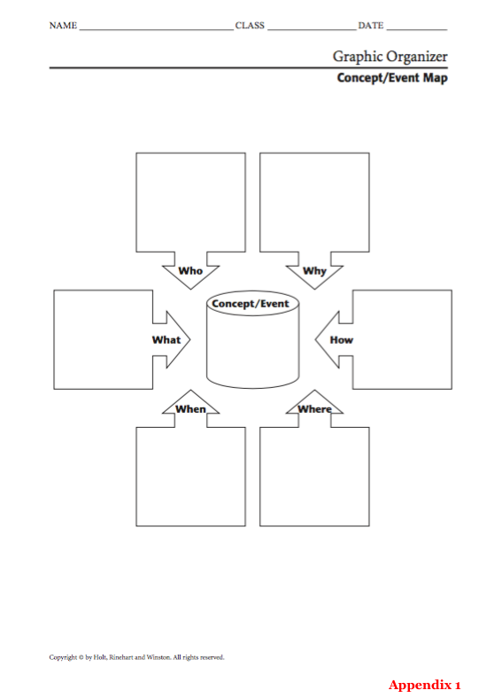

Appendix 2

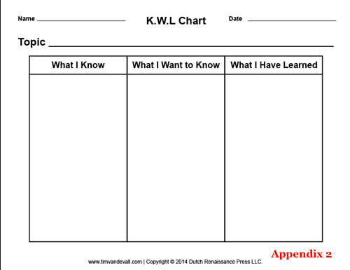

Appendix 3

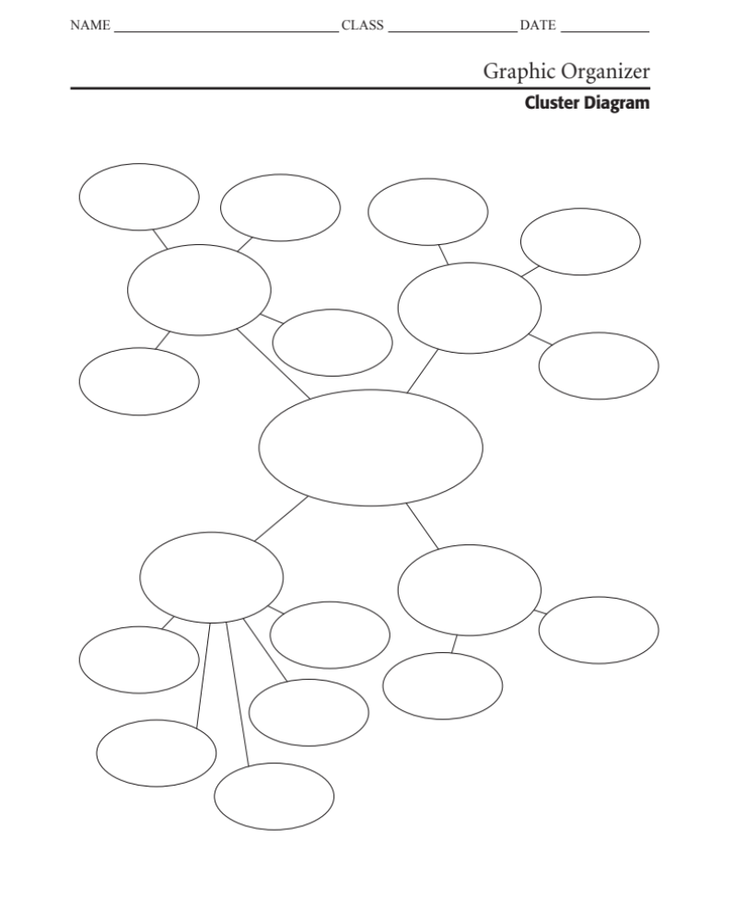

Appendix 4

Photo and Question Slide No. 1

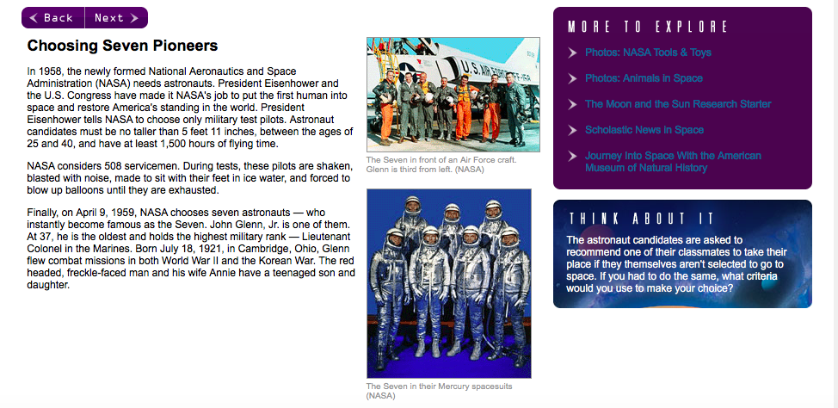

Appendix 5

Photo and Question Slide No. 2

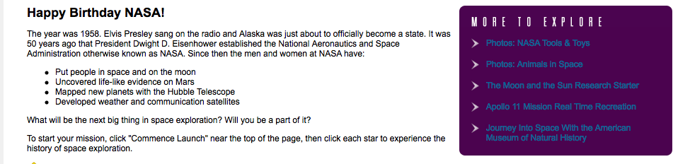

Appendix 6

Photo and Question Slide No. 3

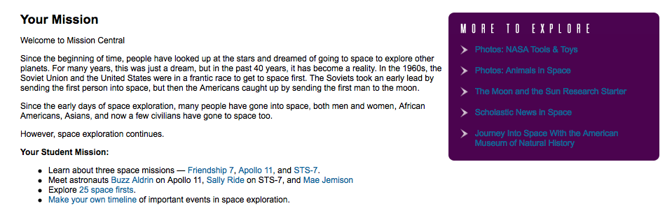

Appendix 7

Photo and Question Slide No. 4

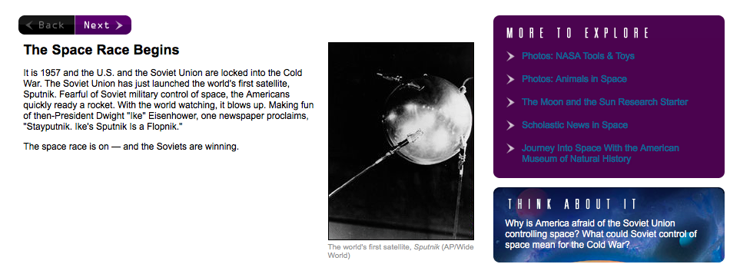

Appendix 8

Photo and Question Slide No. 5

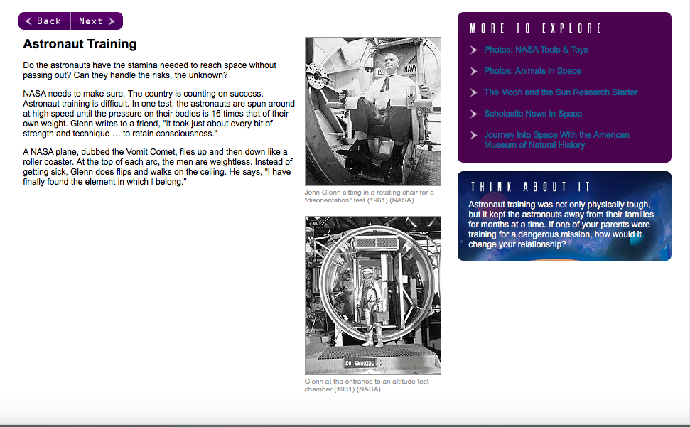

Appendix 9

Photo and Question Slide No. 6

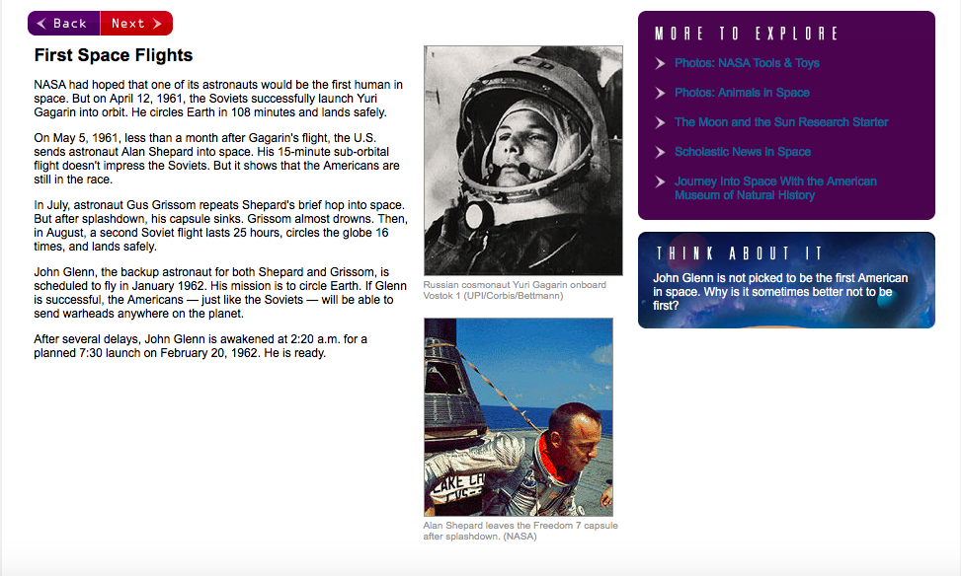

Appendix 10

Photo and Question Slide No. 7

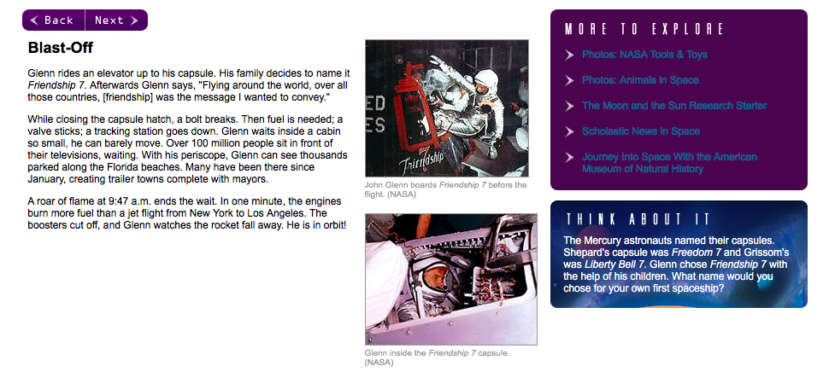

Appendix 11

Photo and Question Slide No. 8

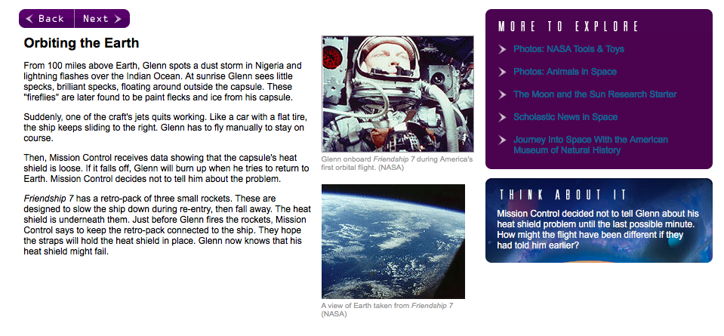

Appendix 12

Photo and Question Slide No. 9

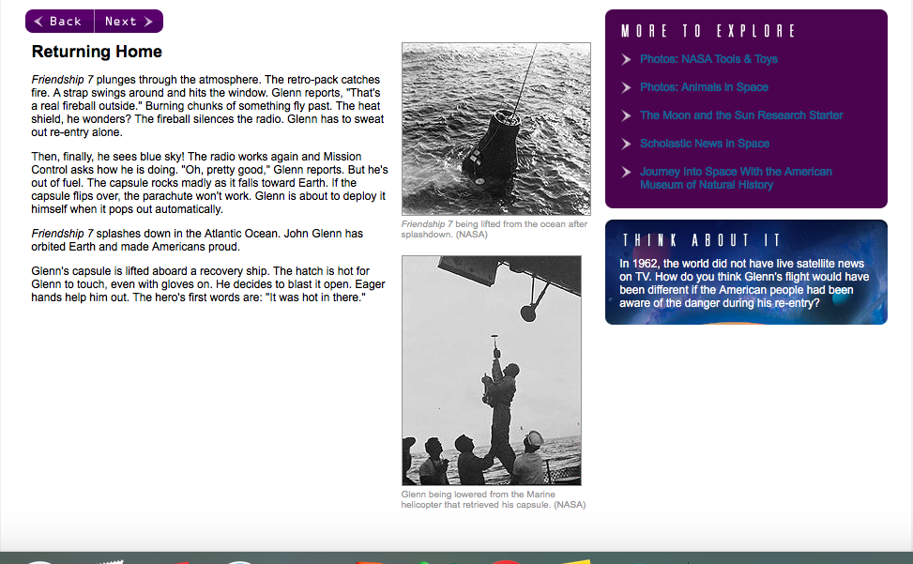

Appendix 13

Photo and Question Slide No. 10

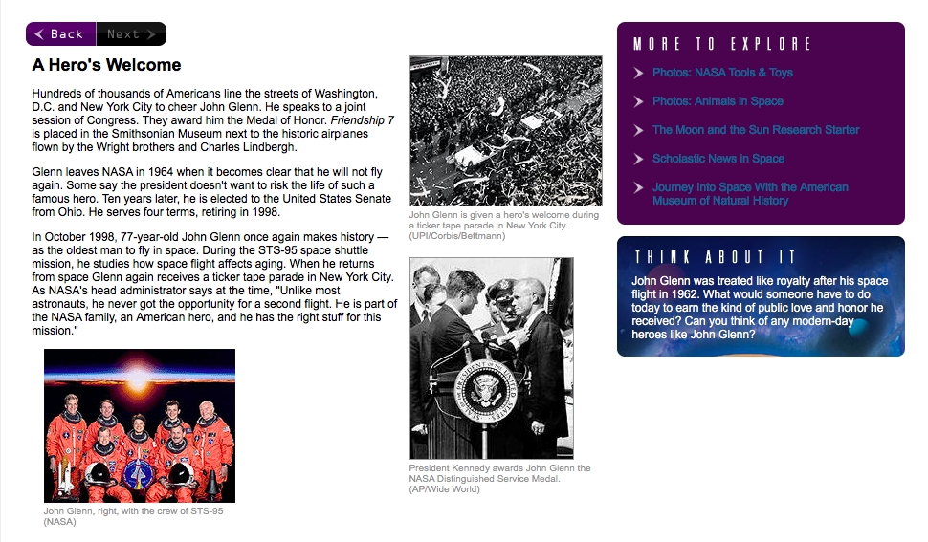

Appendix 14

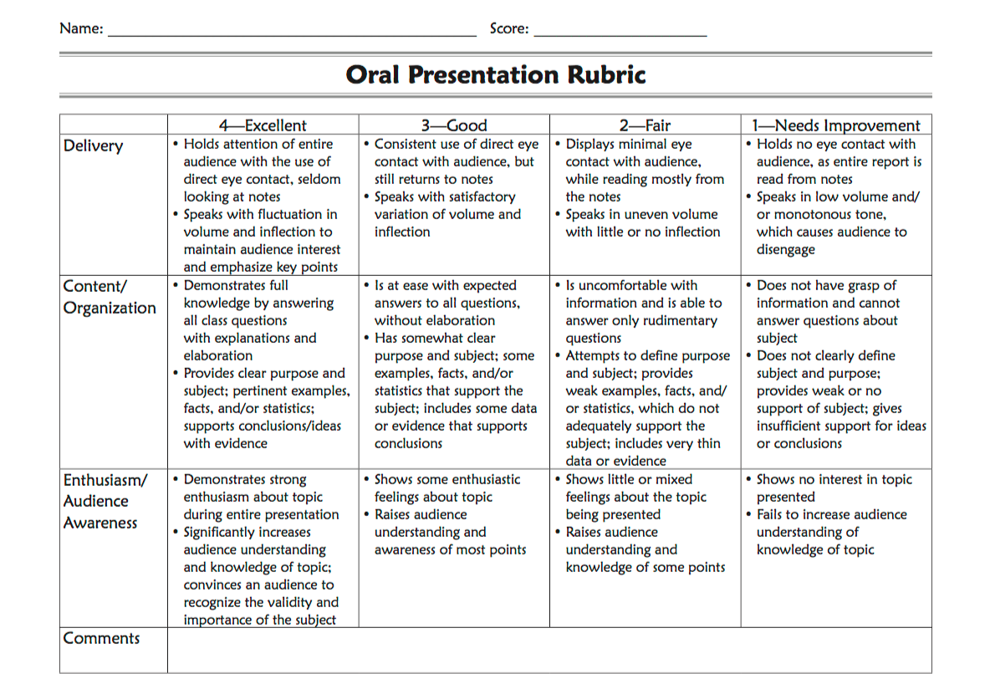

Appendix 15—The Space Race Web Quest

Name ___________________________________________ Class period _____
The Space Race Web-quest
Answer all questions by clicking the various links or watching the videos. Take your time on this, do not rush. Be sure to use complete sentences and provide supporting details when possible.
Part 1: The cold war
Watch the video “Space Race the cold War front” athttp://www.history.com/topics/space-race/videos#the-space-race
1. Early in the race for space, what country was leading the way in terms success in space travel? Why? ________________________________________________________________________________________________________________________________________________________________________________________________

2. What are two of the examples given for Russian “firsts” in space? ________________________________________________________________________________________________________________________________________________________________________________________________
3. What is President Kennedy’s ultimate goal for space travel for the decade of the 1960’s?
Part 2: Sputnik
Go to the page http://www.nasa.gov/externalflash/SpaceAge/ THEN CLICK ON “Launch of Sputnik” (You can mute the sound by clicking on the small speaker in the upper right side)
4. What was Sputnik? How much did it weigh? ________________________________________________________________________________________________

- What did the U.S. fear as result of the Sputnik launch? ________________________________________________________________________________________________

Part 3: Sputnik 2
Go to http://nssdc.gsfc.nasa.gov/nmc/spacecraftDisplay.do?id=1957-002A

6. What was Sputnik 2 and who was the agency that funded it? _______________________________________________________________________________________________

7. What/who was the first being to orbit the earth? ________________________________________________________________________________________________

8. Did it safely return? ________________________________________________________________________________________________

9. What did scientist learn by doing this experiment? ________________________________________________________________________________________________

Part 4: The US space program go to http://www.nasa.gov/externalflash/SpaceAge/
Click on “America enters the space race”
(YOU can mute the sound by clicking on the small speaker in the upper right side)

10. How does the United States respond in relation to Sputnik?
11. What does Explorer 1 discover?
12. What program is created to oversee space exploration efforts?
Watch the video of President John F Kennedy in 1962 speech to the USA! At https://www.youtube.com/watch?v=_RaRC6YuYCQ
13. Reflect on President Kennedy’s speech. What emotions was the president trying to give the crowd? What do you think his goal was in making this speech and do you think he was successful? (Minimum – 2 sentences)
Part 5 NASA: Apollo program go to http://www.nasa.gov/audience/forstudents/5-8/features/nasa-knows/what-was-apollo-program-58.html
14. What years did the Apollo missions take place? ________________________________________________________________________________________________

15. How many astronauts could travel in the newly designed Apollo command module at a time? ________________________________________________________________________________________________

16. Why was the Apollo program important? ________________________________________________________________________________________________________________________________________________________________________________________________
Part 6: NASA’s Next giant leap, the journey to Mars. http://www.nasa.gov/content/nasas-journey-to-mars

17. How long have robotic explorers studied mars? _________________ years.
18. What is NASA planning on redirecting to put into orbit around the moon? ________________________________________________________________________________________________
19. What do scientist think Mars might have had in its past? ________________________________________________________________________________________________
20. When is NASA planning on sending to people to Mars? Is this a good idea why or why not? ________________________________________________________________________________________________________________________________________________________________________________________________________________________________________________________________________________________________

Appendix 16

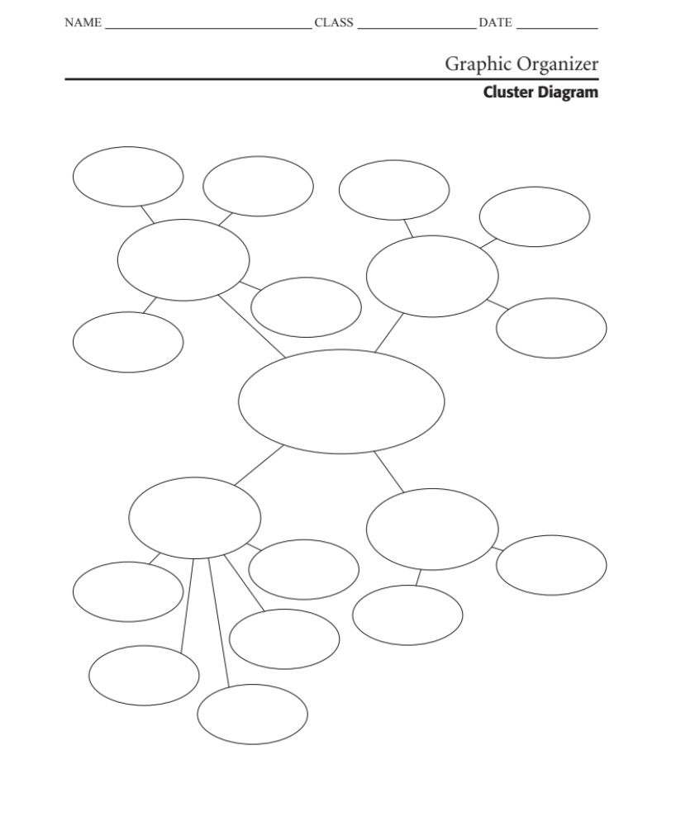

Appendix 17

Name _______________________________

Vocabulary Recognition Task

Moonwalk: The First Trip to the Moon

We will be beginning a unit of study on objects in the sky. Below you will find a list of words. Circle the words that you are able to read and are sure have something to do with outer space. Do not guess, because wrong answers will lower your score.

Asteroid voyage meteoroid
rotation astronomy meteorite
orbit universe comets
probes solar civilian
simulator craters circumnavigation
civilian exploration centrifuge
moonquakes phases galaxy
telescope constellation acceleration

Correctly chosen hits: ___________________________
Incorrectly chosen foils: __________________________
Hits – foils = known words ________________________

Appendix 18

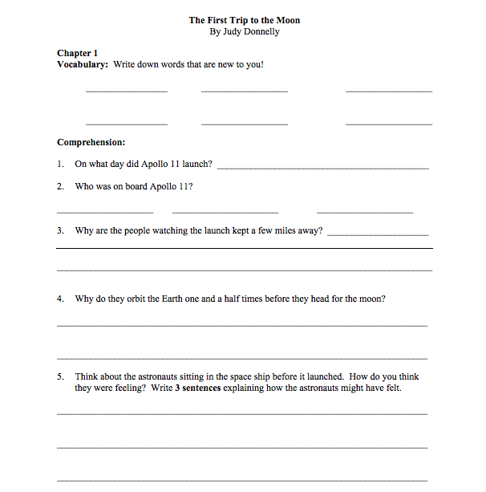

Appendix 19

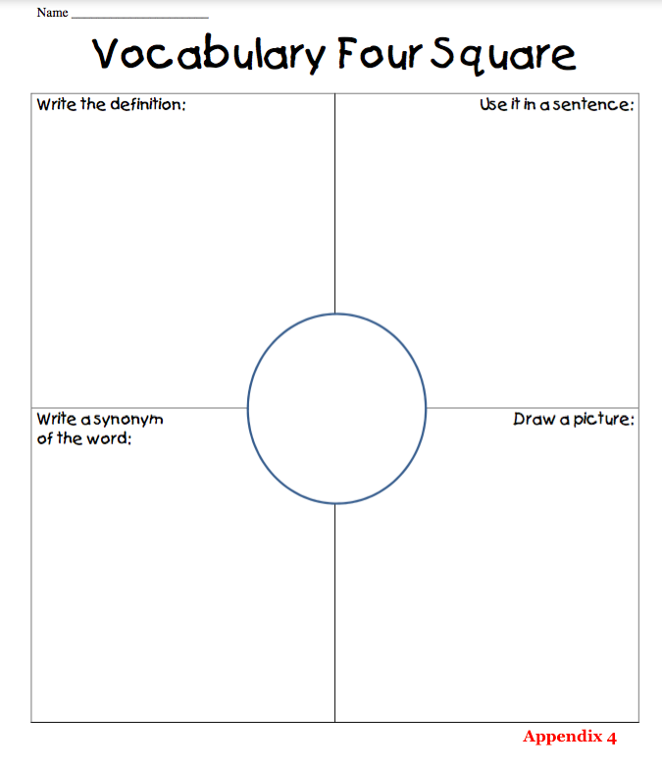

Appendix 20—Formative Vocabulary Assessment

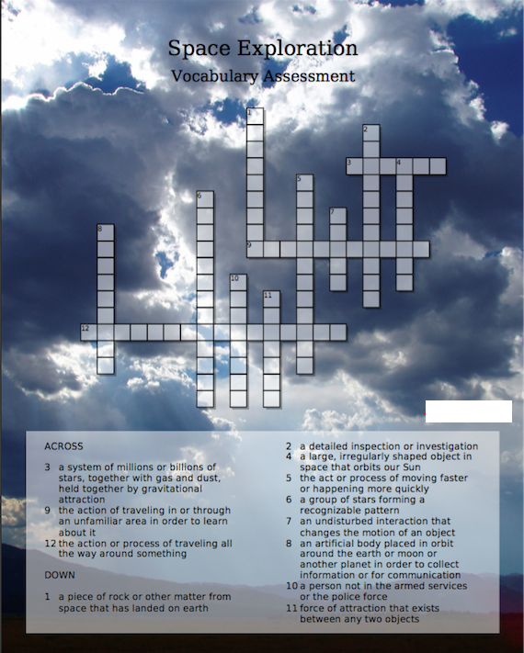

Appendix 21—Vocabulary Assessment Answer Key

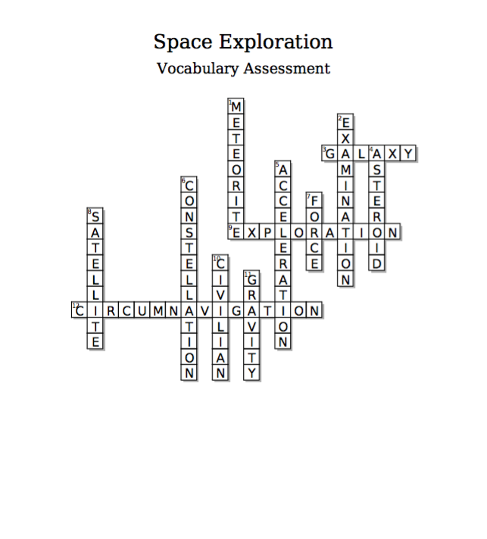

Appendix 22

Space Exploration Timeline

Your 1st Mission
Welcome to Mission Central.
Since the beginning of time, people have looked up at the stars and dreamed of going to space to explore other planets. For many years, this was just a dream, but in the past 40 years, it has become a reality. In the 1960s, the Soviet Union and the United States were in a frantic race to get to space first. The Soviets took an early lead by sending the first person into space, but then the Americans caught up by sending the first man to the moon.
Since the early days of space exploration, many people have gone into space, both men and women, African Americans, Asians, and now a few civilians have gone to space too.
However, space exploration continues.
Your Student Mission:
- Using the following handout, make your own timeline of important events in the history of space exploration. Use ONLY the website provided in this handout.
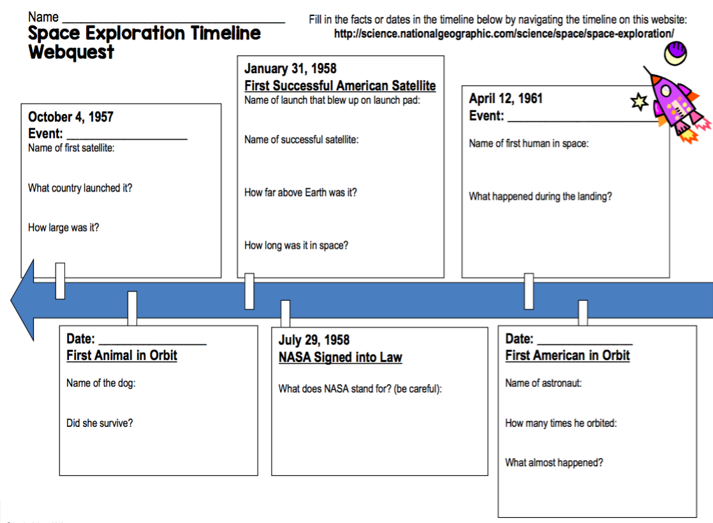
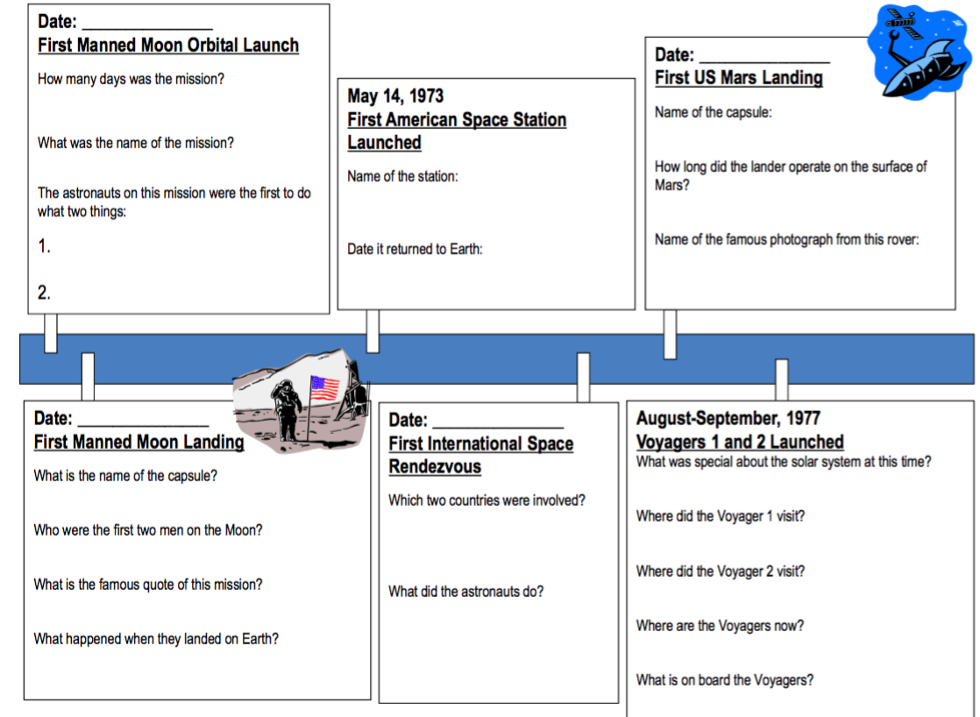

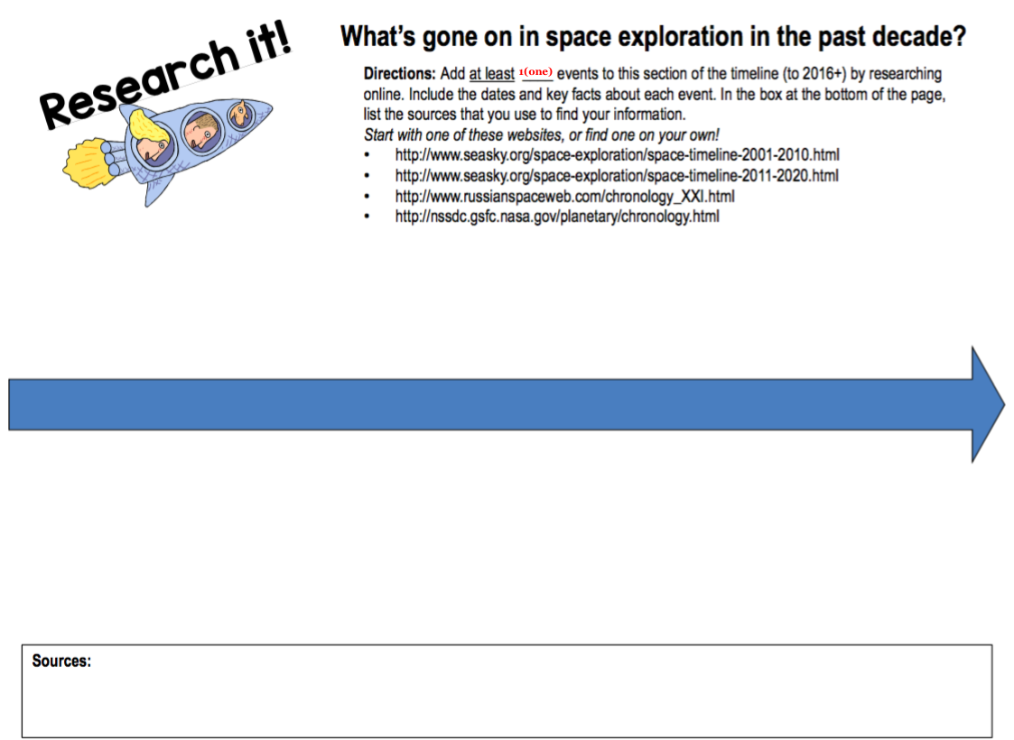
Appendix 23—“Nasa—What Have you done for me lately?” instructions.

Your 2nd Mission

Use the following website to find information for this mission: www.nasa.gov/city

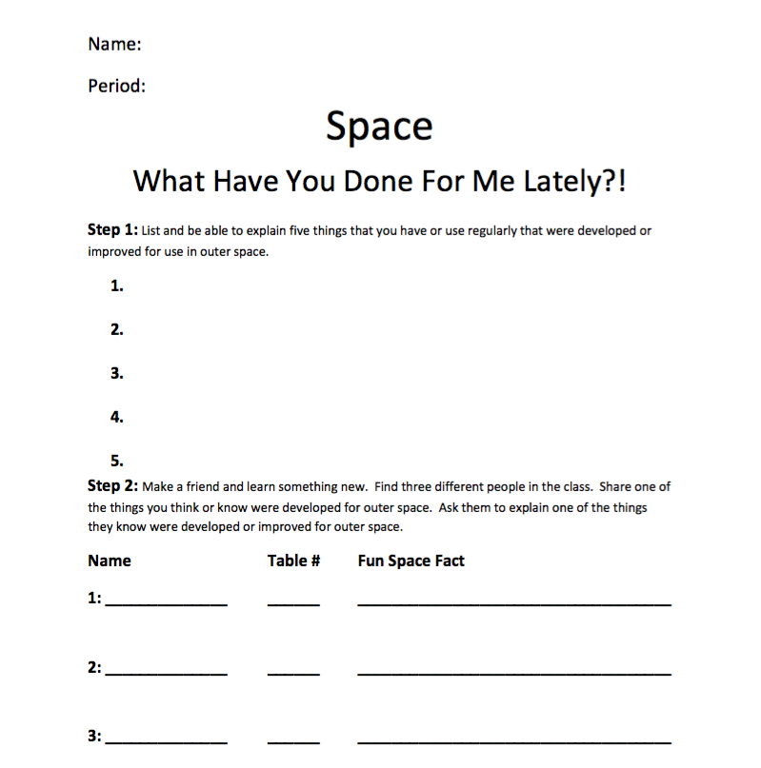

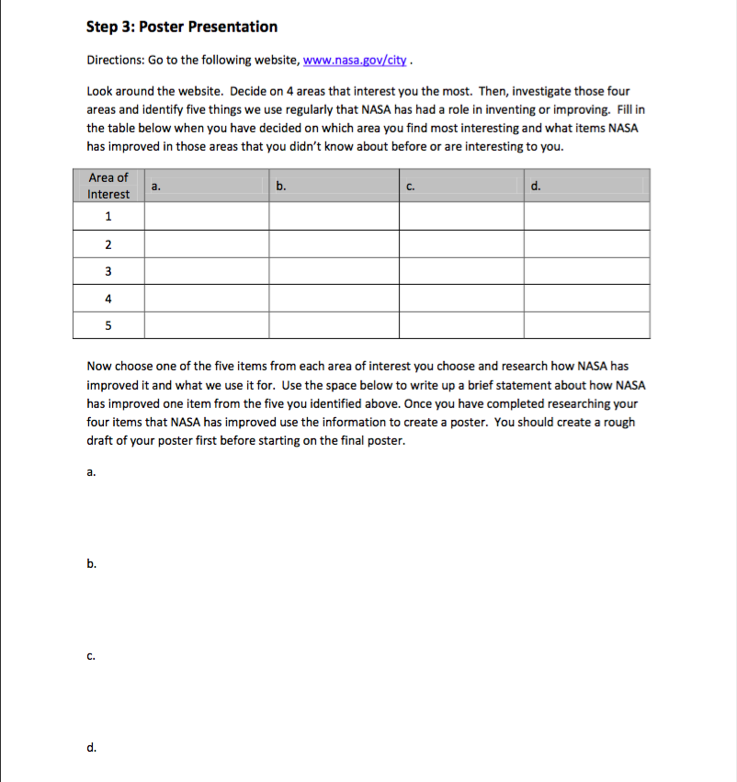

Appendix 24—Comprehensive Multi-Genre Report Instructions

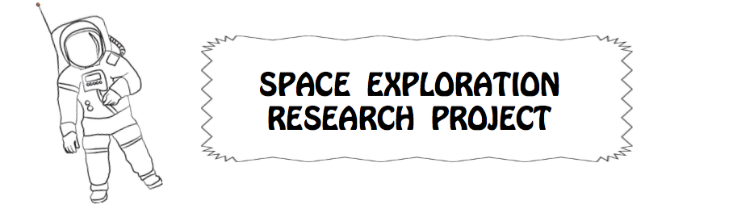
You are about to blast-off on an exciting journey! Your mission is to complete a multi-genre research project on objects in the universe including their movement. To clarify, a genre is a category of works that share a similar style or form. This writing/research project will require that you write on the topic of space exploration by using different styles, or genres, of writing. This mission allows you to showcase what you have learned through your research by writing poems, stories, journal entries, or even cartoons! Why should you accept a mission like this? This quest will help you with the research process while improving your craft with different styles of writing.
Mission:
You are the final commander of this journey. You may work in groups of three or four, but ONLY to collaborate. Ultimately, each student will be responsible for completing his or her own presentation. You will prepare a 5-10 minute presentation, using either PowerPoint, Prezi, IMovie, or another teacher approved application. Your presentation represent the research gathered about space exploration while working on the space timeline, and “NASA—What have you done for me lately?” activities. You may only use websites that have been previously approved, and are posted at the front of the classroom.
Research Criteria:
- You should have a minimum of three sources from which you have gathered information.
- Information to be gathered:
- Major events in the space age (Time Line)
- 3 Major people (astronauts, scientists) that contributed to the space program
- 3-5 Major accomplishments of the Space Age
- Impact of the Space Program
- Any other Important Information
- The inclusion of at least one of the following:
comic strip, poem, journal entries, cartoons, or stories
- Your presentation must also include music as a form of enhancement.
- Music should not overpower the presentation.
- Music should effectively enhance the presentation.
- Music must be appropriate.
- You must include a reflection of your experience with researching the project.
- If working in a group, each member must provide their own reflection.
Presentation Criteria:
- Must include at least 15 slides (frames); or be at least 10-15 minutes long.
- The first slide (frame) must be a cover slide including:
- Title of Project
- Your Name
- Class Period/Teacher Name
- Date
- At least 7-10 graphics or photos
- Background music must be included to enhance presentation.
- Music and pictures must be cited.
- The last slide (frame) must be a bibliography slide including:
- 3 or more sources
- Proper citation for information, music, and pictures
Reflection Criteria:
- Must be a half a page or more, typed.
- Tell three interesting things you learned while researching this project.
- What did you enjoy most about this project?
- What was the most challenging part of the project?
- If you worked in a group, how did you help your group members during the project?
- What would you do differently if you had to redo the project?
- What was something the teacher could have done differently with the project?
What to Hand In:
- Space Exploration Timeline
- “NASA—What have you done for me lately?” research and poster board.
- Printout of PowerPoint slides OR pdf of Prezi. (Or any paper material the teacher deems appropriate if using a different application.)
- Reflection
- Rubric

Appendix 25

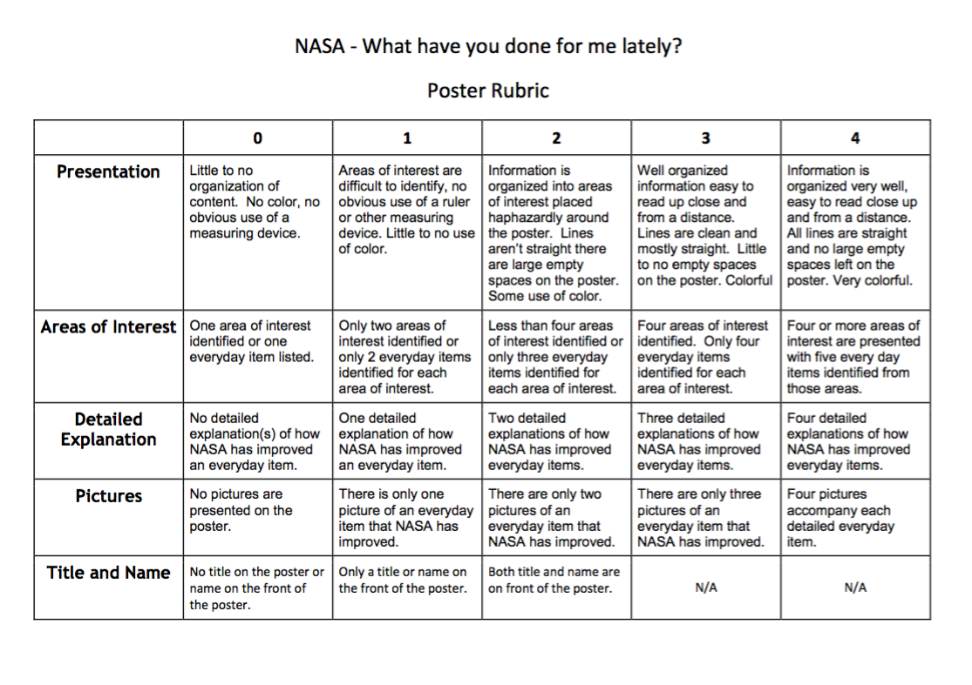

Appendix 26

Oral Presentation Rubric

Appendix 27—Overall Report Rubric

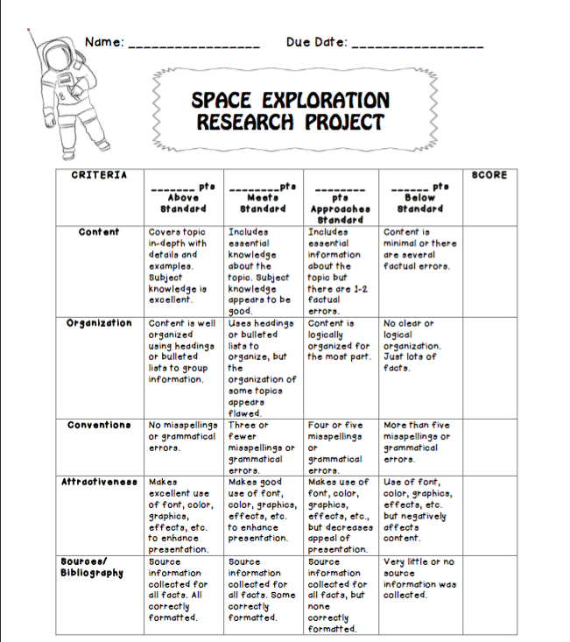

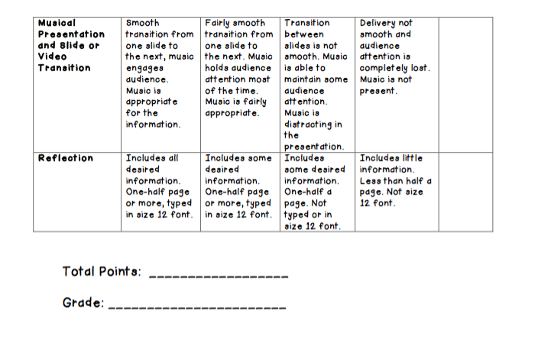

Appendix 28—Student Conference Checklist

 Student Conference Checklist

This conference will be done on the second workday of the Multi-Genre Research project. The teacher will evaluate the students’ work thus far and will provide feedback for the student.

- Is there inclusion of music present? ____
- Is the student documenting the sources from which they pull information? ________
- Thus far, is the work on topic, developed, and organized? ____________
- Does the student demonstrate a solid understanding of the topic? __________
- Does the student have a plan for the “connectors” that will link each writing genre? __
- Does the student need clarifications regarding grammar or mechanics? _________
- Does the student have any questions that they would like answered or clarified? ______
- Is the student “on-target” for completion of the project? __________
- Notes/Concerns: ________________________________________________________________________________________________________________________________________________

Appendix 29

Appendix 30

“Dizzy Mice”

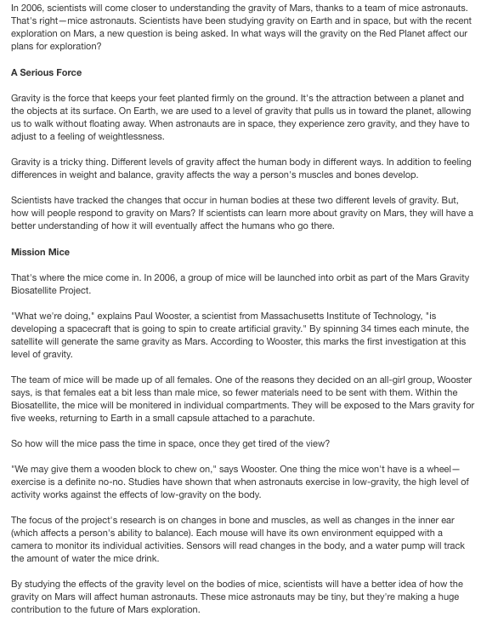

Appendix 31

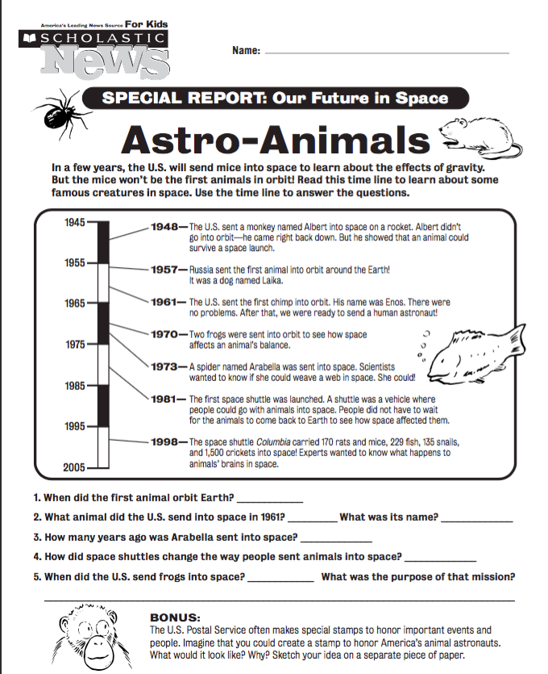

Appendix 32

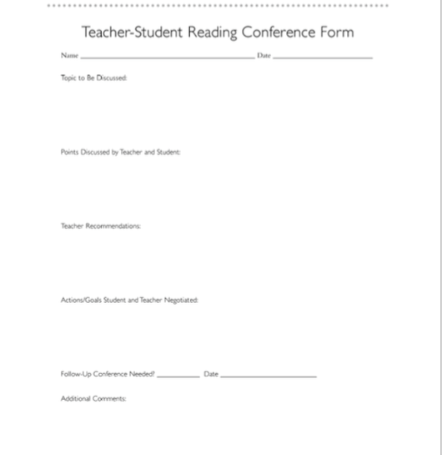

Appendix 33

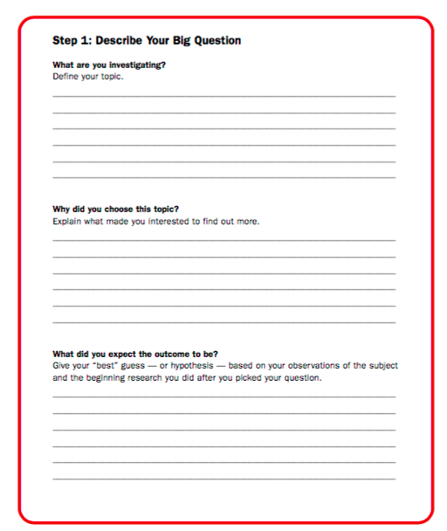

Appendix 34

Appendix 35

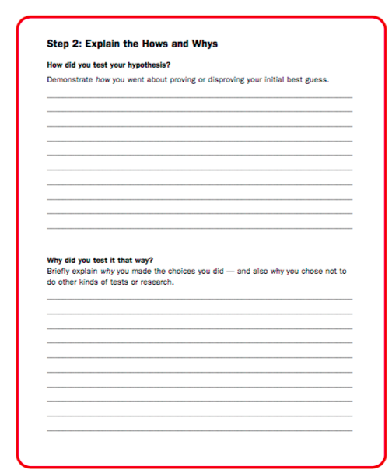

Appendix 36

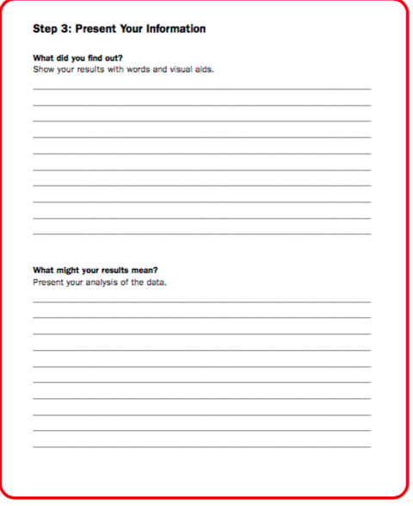

Appendix 37

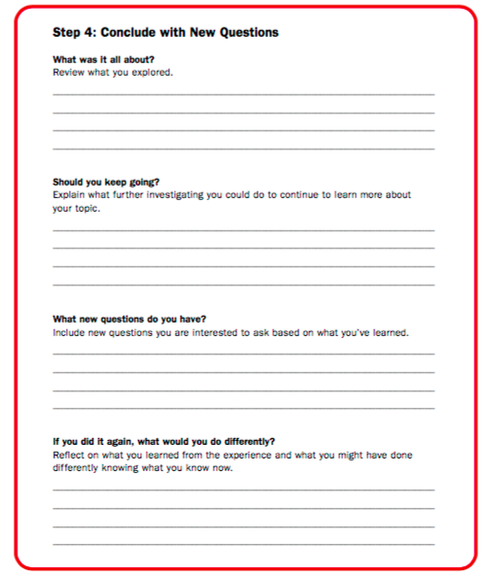

Appendix 38

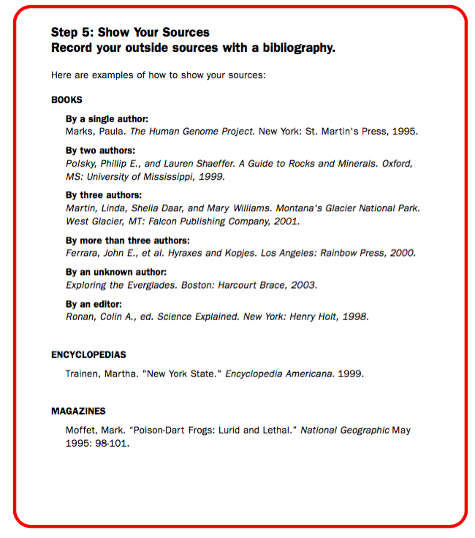

Appendix 39

